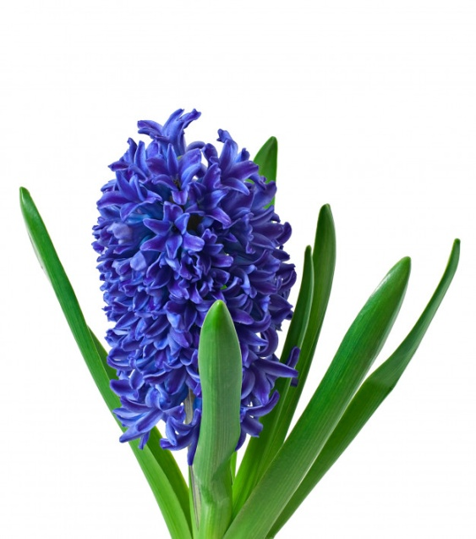 | 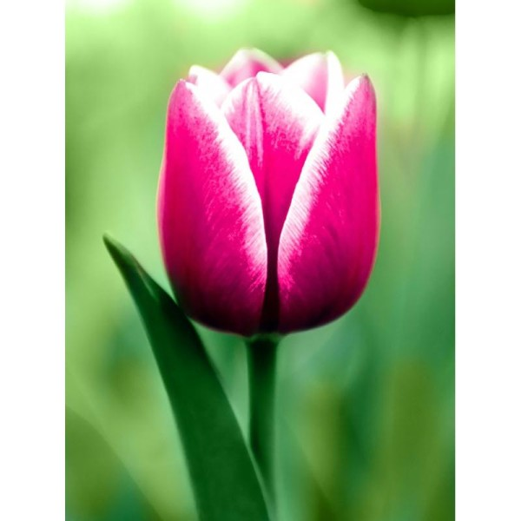
LA JACINTHE  la jacinthe  la jacinthe | LA TULIPE  la tulipe  la tulipe
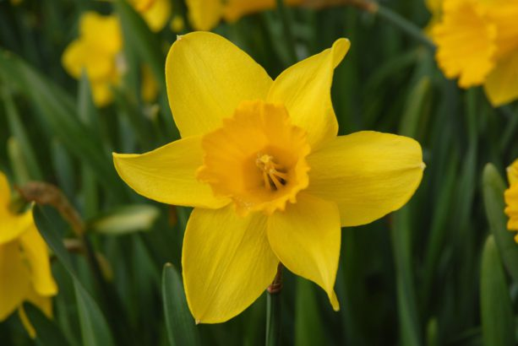 | 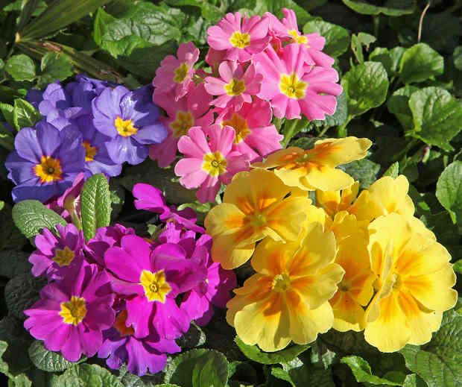
LA JONQUILLE  la jonquille  la jonquille | LES PRIMEVERES  les primevères  les primevères

