 | 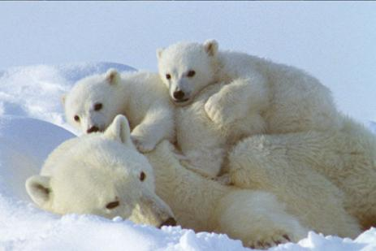
SUPPLIER, IMPLORER  supplier, implorer  supplier, implorer | SE PELOTONNER  se pelotonner  se pelotonner
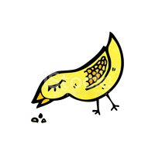

PICORER
picorer
picorer

